ESRI Story Maps—Map Journal

Activity Guide

*Incorporate images & text to create a spatial narrative with Story Map Journal. We will work on the beginning of a story on James Cook’s First Voyage (1768-1771).*

Getting Started

Login to ArcGIS Online ([www.arcgisonline.com](http://www.arcgisonline.com)) with your NCSU-affiliated account

If you don’t have an NCSU-affiliated account:

Create a public account and sign in to Story Maps

<https://www.arcgis.com/home/createaccount.html>

1. Download the Map Journal folder from <http://go.ncsu.edu/storytelling-gis>

a. Go to My Stories: <https://storymaps.arcgis.com/en/my-stories/>

b. On the My Stories page select ‘CREATE STORY’

c. Select ‘Map Journal’

d. Select the Side Panel layout (should be selected by default) and click Start.

e. Give your map a title: James Cook’s First Voyage

f. You’ll be prompted to add “Main Stage Content.” We’re going to create a map.

g. Add - Add Layer from File - select [JournalSpreadsheet_CookVoyage.csv](https://drive.google.com/drive/folders/1Up152zmUmeyU6j9UouQaGJfRZNlg9lb6) in the Map Journal folder. Import layer.

h. Style the points as Location - single symbol. Save your map and close.

I. Click Next and add your Section Title and Side Panel Content (use the [CookMapContentScript](https://docs.google.com/document/d/1pMASh81gMO6b63YzVmrIX_QuwjsK8Dx8DdUAn_IjQi4/edit#) document). Save.

2. Title, Settings, & Basemap

a. Click ‘Settings’ and customize the layout options, theme, and fonts as you’d like.

d. Click save.

3. Continue adding sections with Main Stage content, Side Panel Content, and Section Titles from the [CookMapContentScript](https://docs.google.com/document/d/1pMASh81gMO6b63YzVmrIX_QuwjsK8Dx8DdUAn_IjQi4/edit#) document.

a. Customize the sections and images as you’d like. For instance, experiment with image layouts (Fill, Center, etc)

4. Experiment with Story Actions

a. After you add your Side Panel content, you can select text and add “Story Actions,” which are interactive features. We’ll use the example of the November 1768 Rio de Janeiro section, but you can do this with any of the places mentioned in the content.

b. With the Edit window still open (click the Pencil icon if you’ve closed it), go to the Side Panel edit window and select the text “Rio de Janeiro.” This will enable the Story Actions, which were previously grayed out.

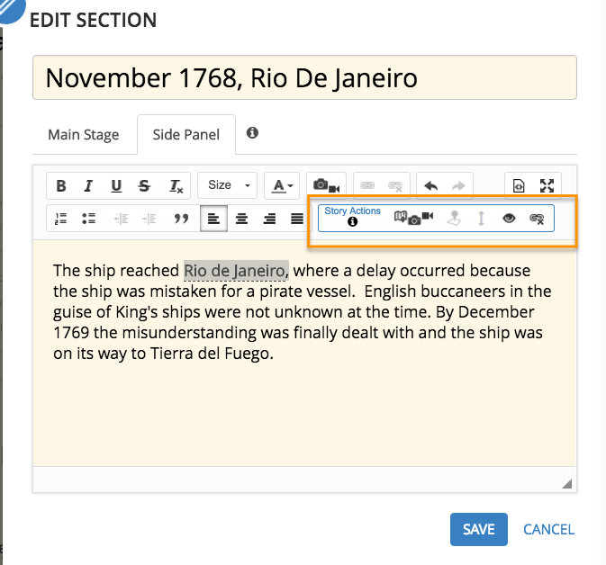

c. Next, click the icon that has a map and camera (“change the main stage content”), and select the map we created in the beginning. We’re going to choose a custom configuration for Location and Pop-up.

NOTE: You can also link to other sections using Story Actions.

d. Location: zoom to the city on the map that you selected in your text. Save.

e. Pop-up: click on the icon for the city you’re selected. Save. Apply.

f. Now click on the city in your side panel and you’ll see the map! The Back button takes you back to your Main Stage Content.

3. Sharing Your Map:

a. Click SHARE at the top of your story map.

b. If you select Share publicly, you will receive a URL link you can use to share the

published version of your Story Map.